Software Requirement Specification Document

For

Portfolio Website Builder

Table of Contents

CONTENTS | PAGE NO
Introduction | 3
Overall Description | 4
Diagrams | 5
External Interface Requirements/Screenshots | 38
Other Non-Functional Requirements | 39
Testing | 40
Conclusion | 50
References | 50
Acknowledgements | 51

- Introduction
  - Purpose
•The software is intended to be a portfolio website builder.
•Users can effortlessly create professional websites for their portfolios using this tool.
•It fixes the problem of saying that a web developer's help is needed for making a website.
•The system offers basic templates and user-friendly personalization options.
•Therefore, the SRS document here is to notify about the features, requirements
•It serves both developers and users as a reference

  - Intended Customers/Users
•Students -Students can make portfolios that include all their school projects, skills they have learned and any certificates they have received.
•Job seekers –Job seekers can highlight their work experience, skills, and achievements to attract employers.
•Freelancers -Freelancers can display past projects and client work to attract potential clients.
•Professionals –Professionals can highlight career growth, expertise, and accomplishments for networking and advancement.
•Administrators –Administrators can manage users, monitor content, and maintain system security and performance.

  - Product Scope
•Personal portfolio web sites are to be created.
•Portfolio templates will be tailored.
•Sections like About, Skills, Projects, Resume, and Contact will be added.
•Images and documents will be uploaded.
•Users will be able to see the portfolio before it is live.
•The portfolio will be available online.
•Users will be able to access the portfolio on various devices.

  - Outline of the document
•The first chapter covers the introduction, the aim, and the extent of the work.
•The second chapter looks at the whole system and the users.
•The third chapter contains the functional and non-functional requirements.
•The fourth chapter deals with the user interface requirements.
•The fifth chapter talks about the performance and security requirements.
•The sixth chapter describes black-box and white-box testing approaches.
•The seventh chapter summarizes the project.
• The eighth chapter lists cited materials.
• The nineth chapter recognizes contributors.

- Overall Description
  - Product Perspective
•The system is designed for operation in an online environment.
•The model enables the users to access by means of a web browser.
•It uses a client-server setup.
•The system operates independently.
•The user manual is supported through a database that contains userdetails
•There could be communications with outside services like email services.
•The system allows multiple users to access at a time
•You can access the system using a desktop, a laptop, a tablet and mobile devices.

  - Product Functions
•Registration of users as well as their login.
•Feature for recovery of password.
•Portfolio web pages creation and editing.
•Portfolio templates selection and customization.
•Addition of sections like about, skills, projects, resume, and contact.
•Images and documents uploading.
•Preview of portfolio before making it public.
•Public and update of portfolio on the web.
•Admin overseeing user and template management.

  - User Classes
•Student (Basic Access)–The student will use the system to create and manage an academic portfolio.
•Professional / Freelancer (Premium Access) –Freelancers use the system to showcase their work experience.
• Administrator (Full Access)–Administrators have the ability to manages users, templates, and system activities.

2.4Design and Implementation Constraints
•There is a need for an internet connection.
•A modern web browser is necessary.
•Every user is allocated limited storage space.
•It is a must to comply with the data privacy regulations.
•It is dependent on server availability.
•Support for very old browsers might not be provided.
•User Authentication is a requirement for security reasons.

- Diagrams
  - UML Diagrams
A) USE CASE DIAGRAMS
1)Module name:User registration and login module
Description:This module lets people create an account, log in to the system, and log out when done. If they forget their password, they can recover it easily to regain access.
Diagram:
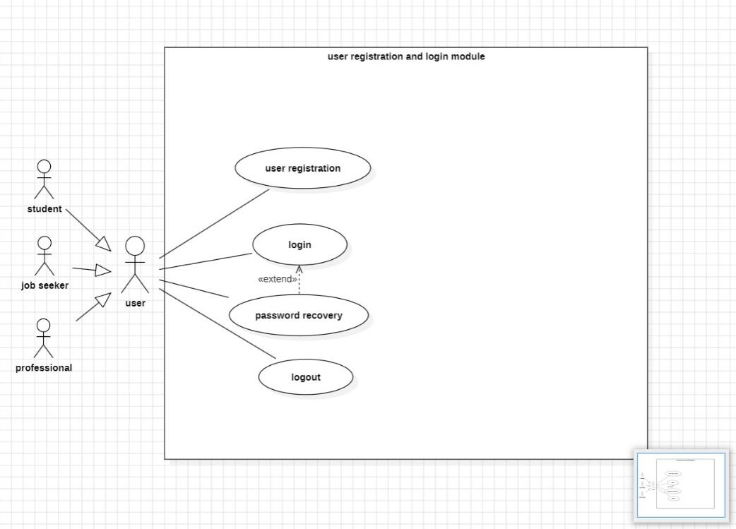

Primary Actor:User
Secondary Actors:Email service, User database
2)Module name:Template selection module
Description:The Template Selection module lets users browse and pick a template they like. They can also customize it to make it fit their needs before using it.
Diagram:

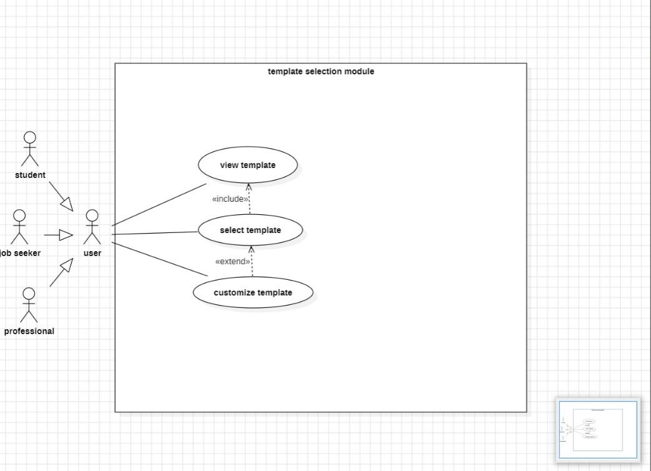

Primary Actor: User
Secondary Actor: Template Database

3)Module name: Portfolio creation module
Description:The Portfolio Creation module lets users build their portfolio by adding sections like
About, Skills. They can also upload images and documents to make their portfolio complete.
Diagram:

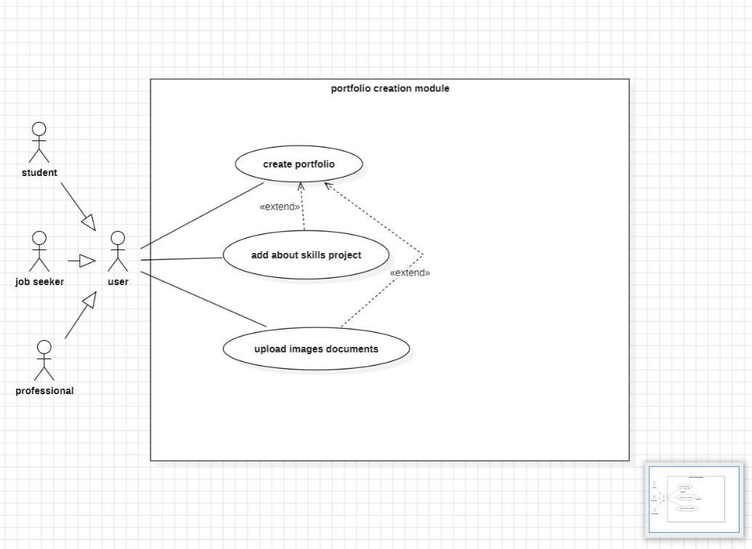

Primary Actor:User
Secondary Actors:Portfolio Database, Media Upload Service.

4)Module name:Portfolio management module
Description:The Portfolio Management module lets users view and preview their portfolio to see how it looks. They can also edit details or publish it when it’s ready to share.
Diagram:

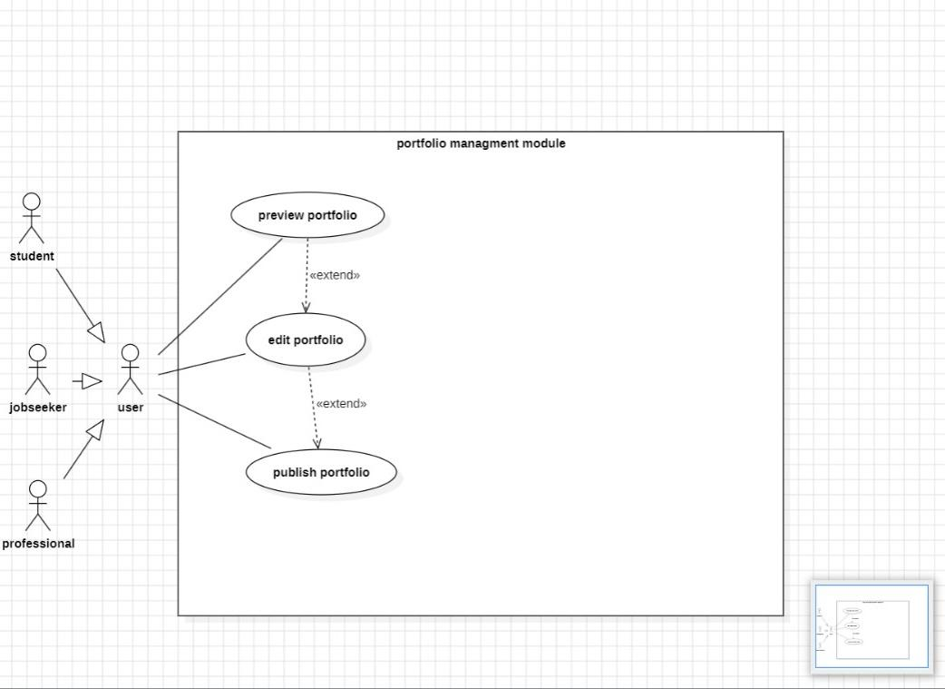

Primary Actor:User
Secondary Actor:Portfolio Database
5)Module name: Preview and publish module
Description:The Preview and Publish module let users check how their portfolio looks before sharing it. They can publish it, share it with others, or unpublish it whenever needed.
Diagram:

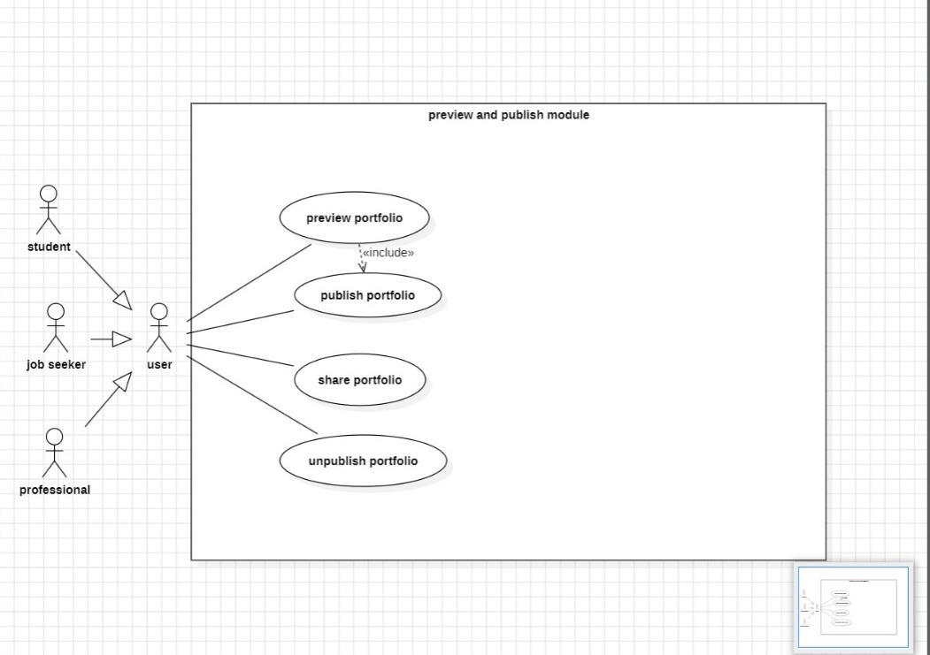

Primary Actor:User
Secondary Actors:Preview System, Hosting Server

6)Module name:Admin management module
Description:The Admin Management module lets administrators manage users and templates,
keep the system running smoothly and monitor performance through analytics.
Diagram:

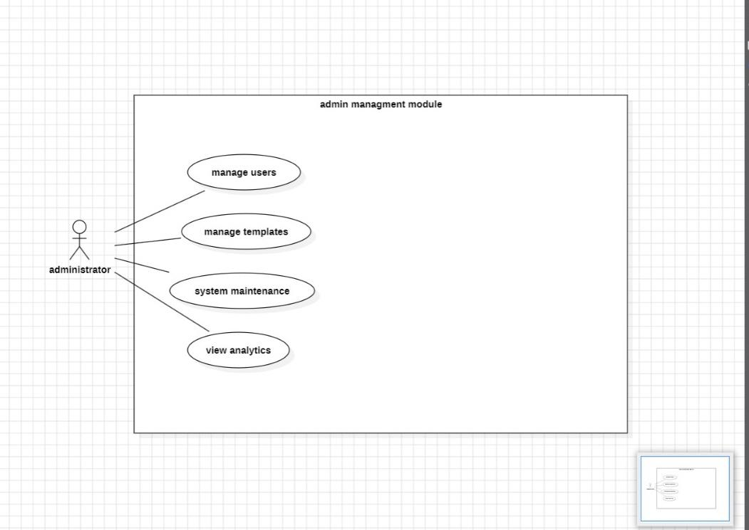

Primary Actor:Admin
Secondary Actors:Database, Server System

B) CLASS DIAGRAMS
1)Module name:User registration and login module
Diagram:

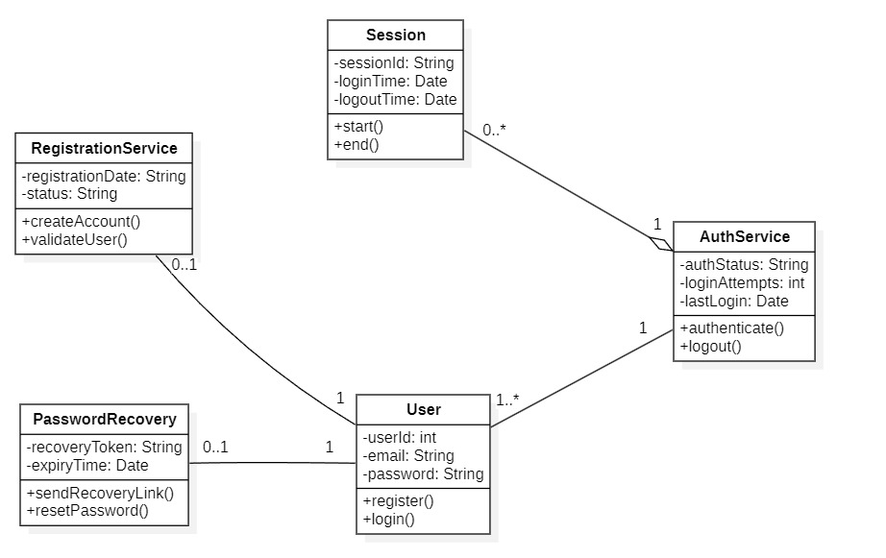

2)Module name:Template selection module
Diagram:

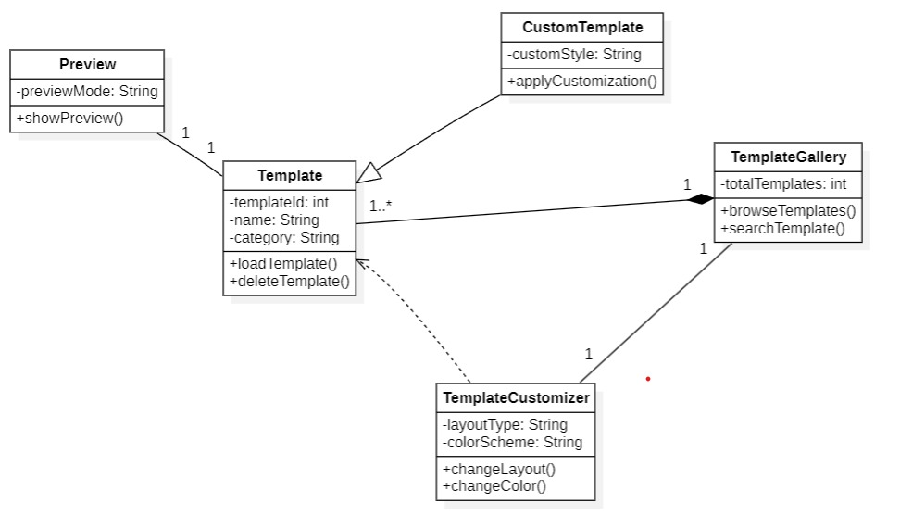

3)Module name: Portfolio creation module
Diagram:

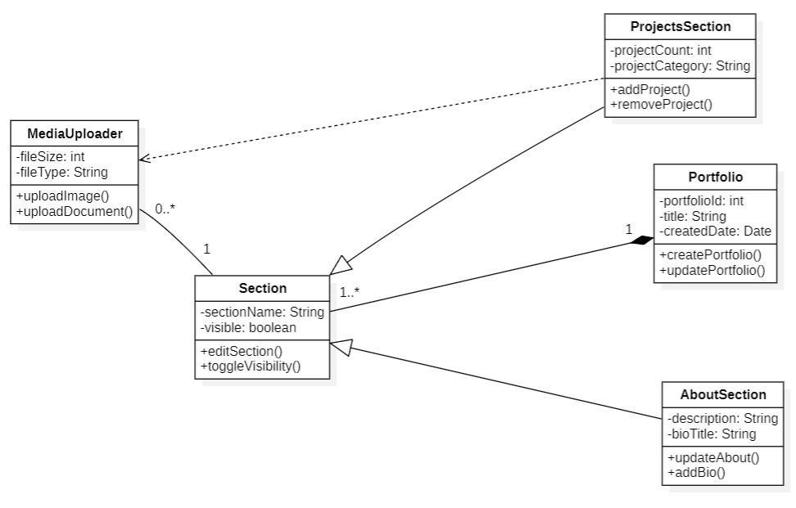

4)Module name:Portfolio management module
Diagram:

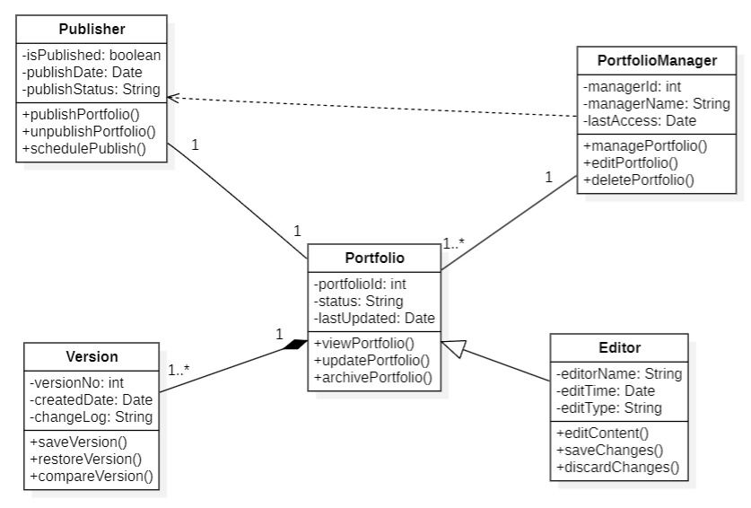

5)Module name: Preview and publish module
Diagram:

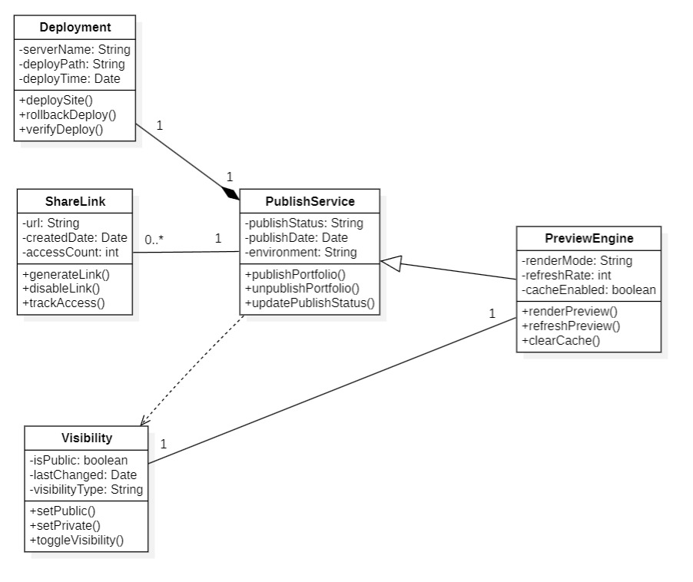

6)Module name:Admin management module
Diagram:

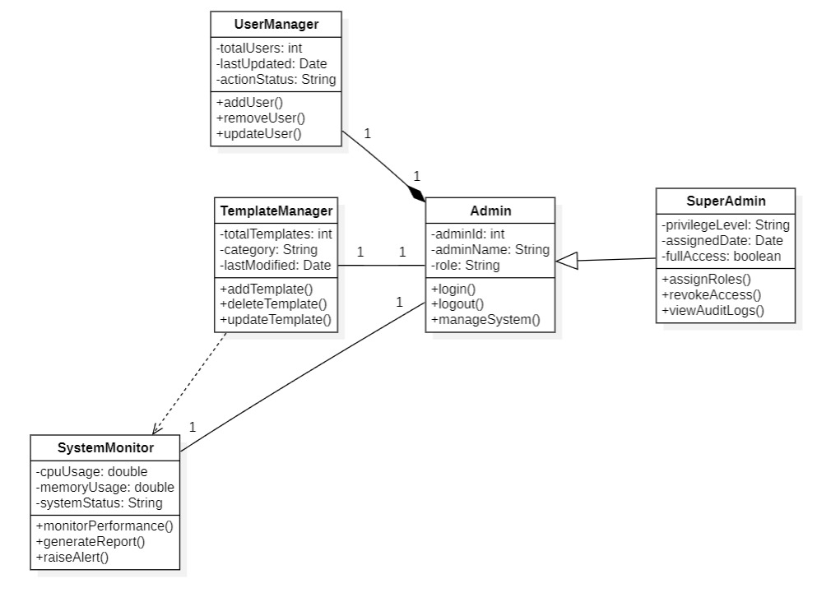

C) STATE CHART DIAGRAMS:
MODULE:User registration and login module.
1)User:

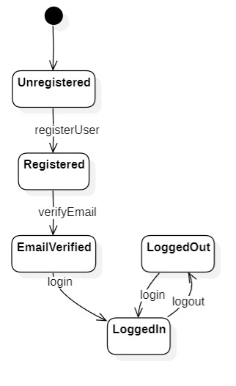

2)Registration Service:

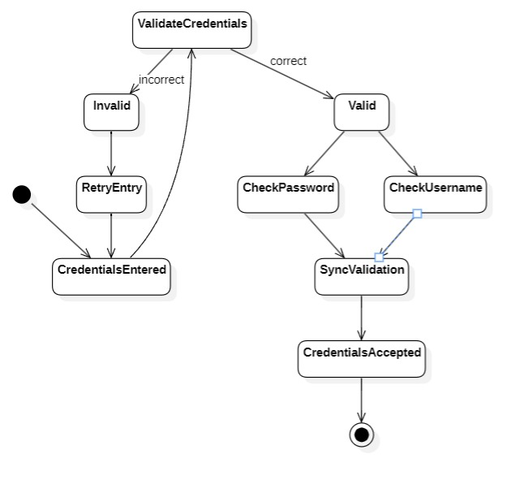

3)Auth Service:

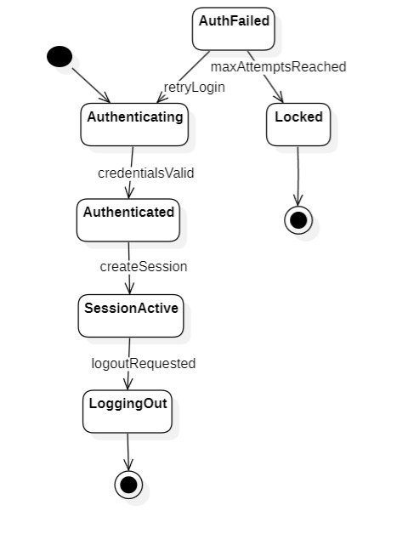

4)Session:
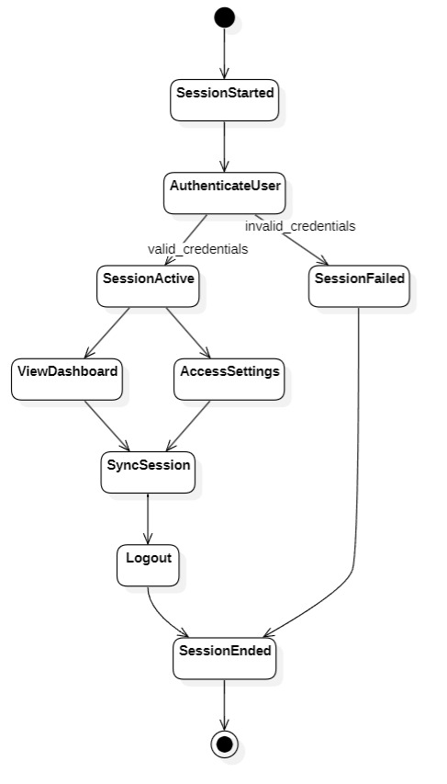
5)Password Recovery:

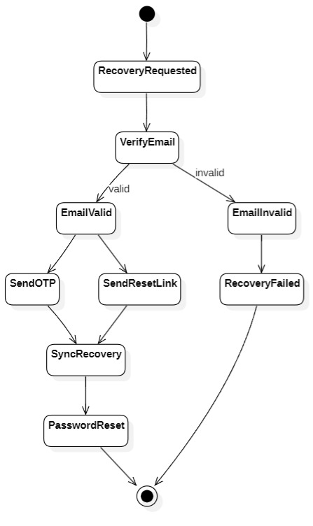

D) ACTIVITY DIAGRAMS:
Module name:Template selection module
Diagram:
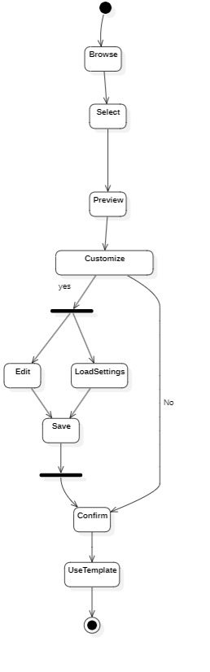

Module name:Portfolio creation module
Diagram:
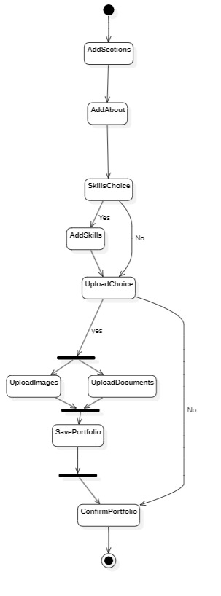
E) SEQUENCE DIAGRAMS:
1)MODULE:User registration and login module.
Diagram:

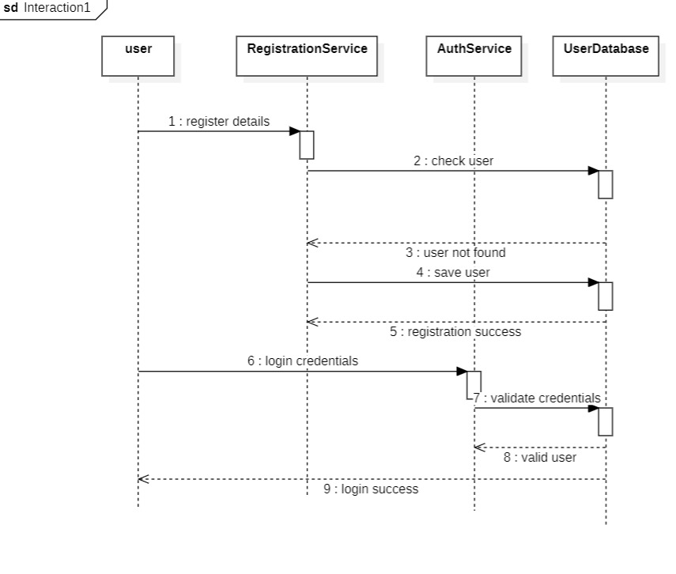
2)MODULE:Template selection module
Diagram:

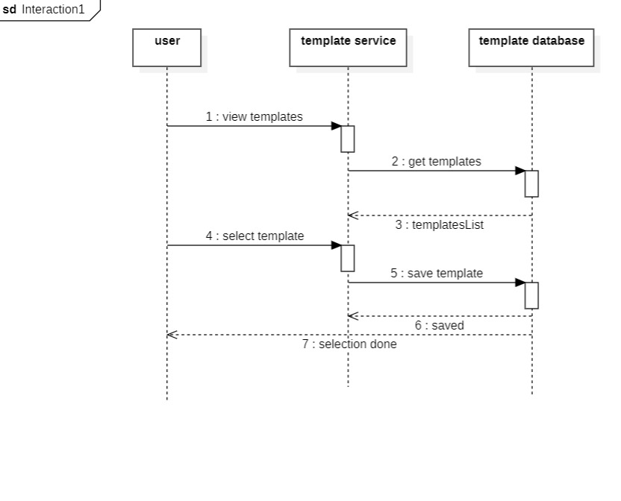
3)MODULE:Portfolio creation module
Diagram:

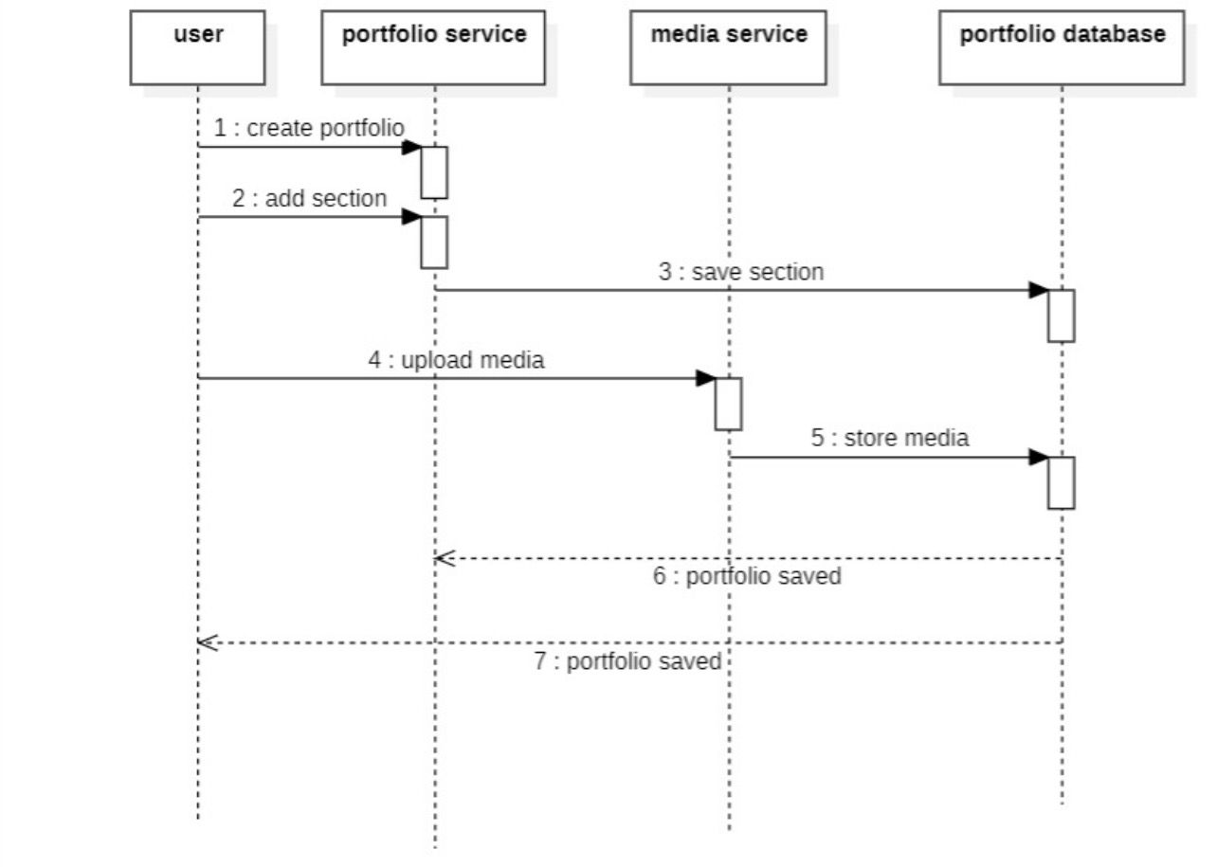

4)MODULE:Portfolio management module
Diagram:

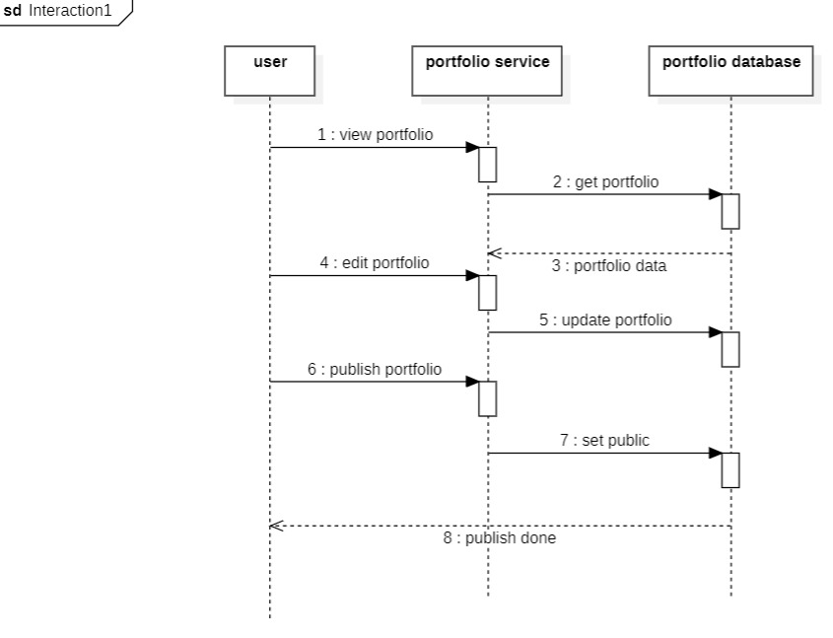

5)MODULE:Preview and publish module
Diagram:

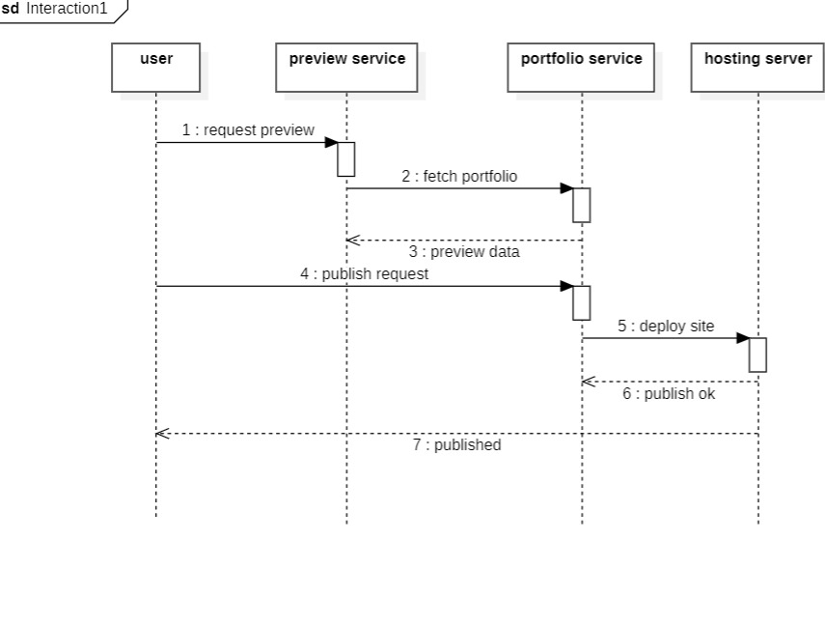

6)MODULE:Admin management module
Diagram:

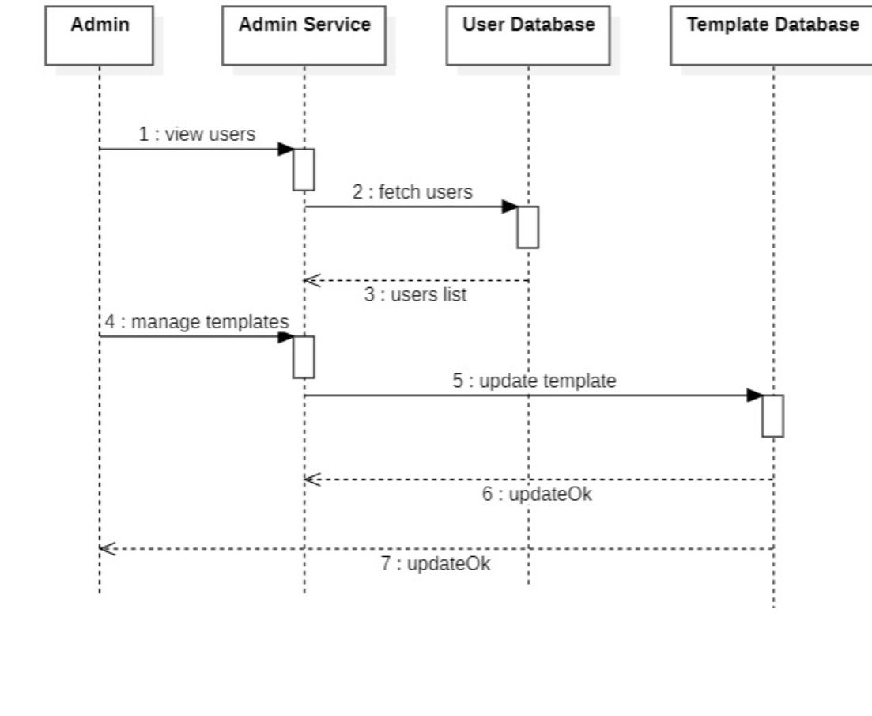

F) COLLABORATION DIAGRAMS:
1)MODULE:User registration and login module.
Diagram:

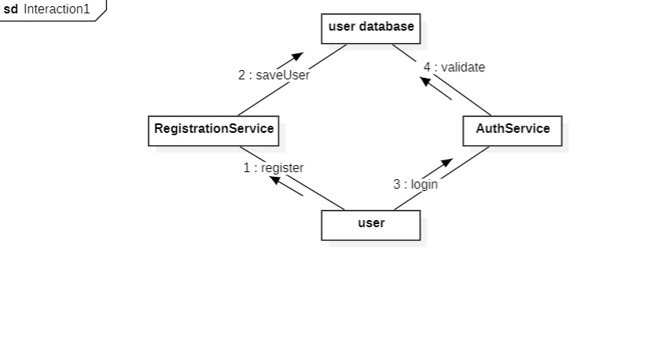

2)MODULE:Template selection module
Diagram:

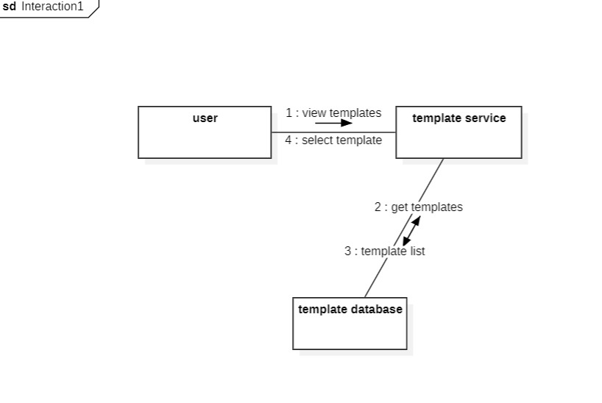

3)MODULE:Portfolio creation module
Diagram:

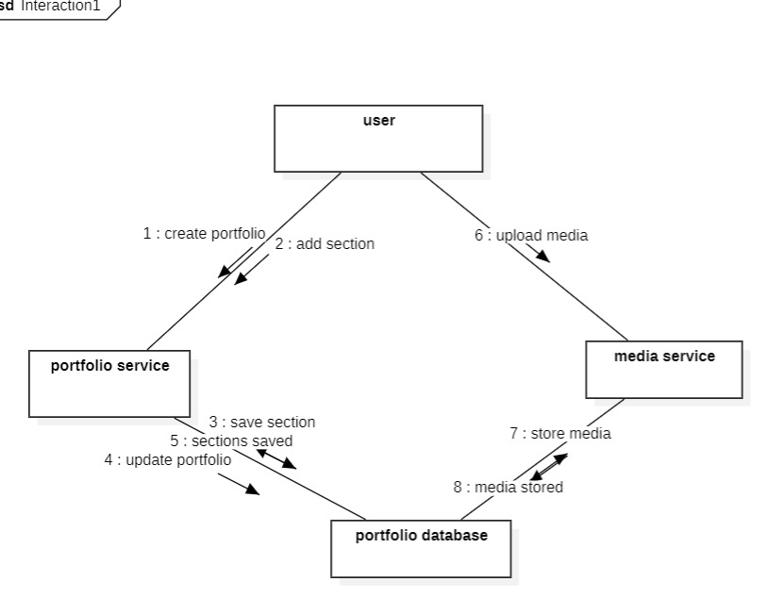

4)MODULE:Portfolio management module
Diagram:

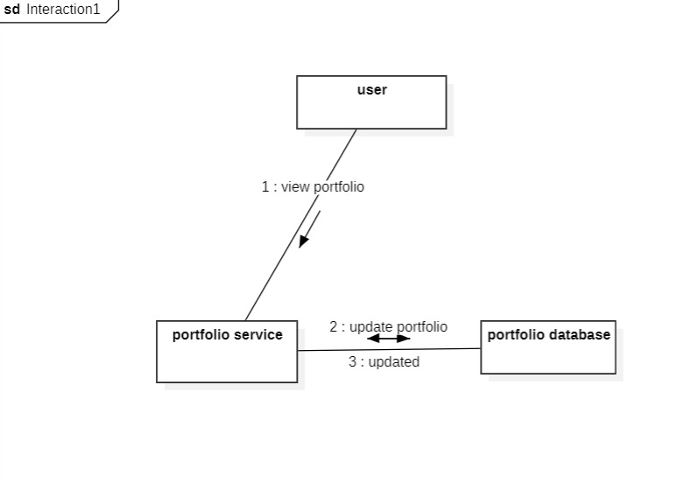

5)MODULE:Preview and publish module
Diagram:

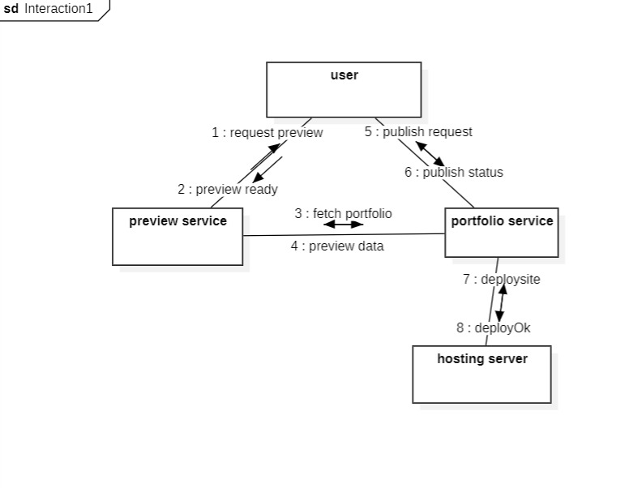

6)MODULE:Admin management module
Diagram:

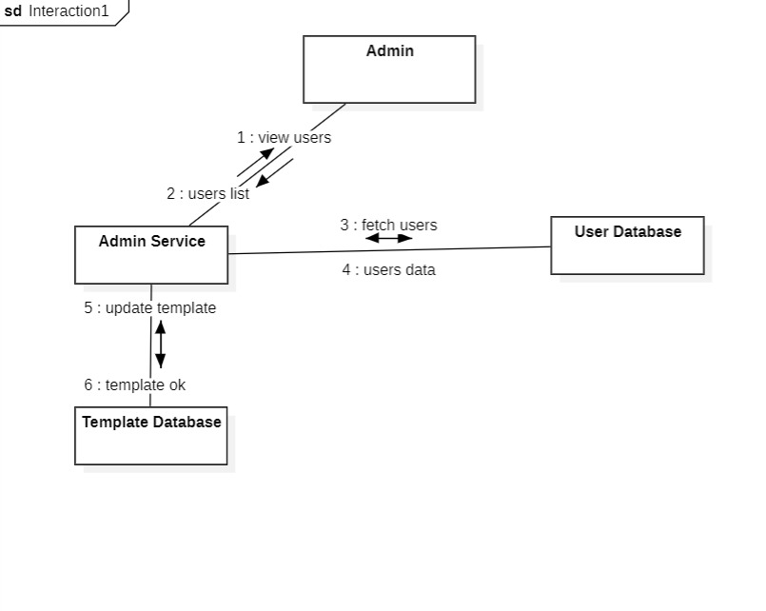

  - ER Diagrams

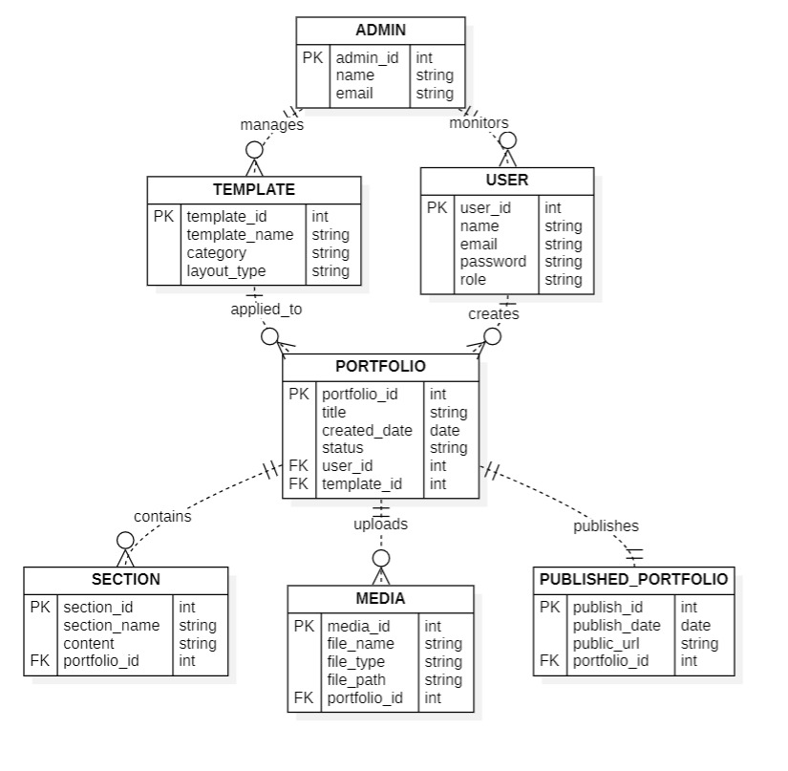

  - DFD Diagrams

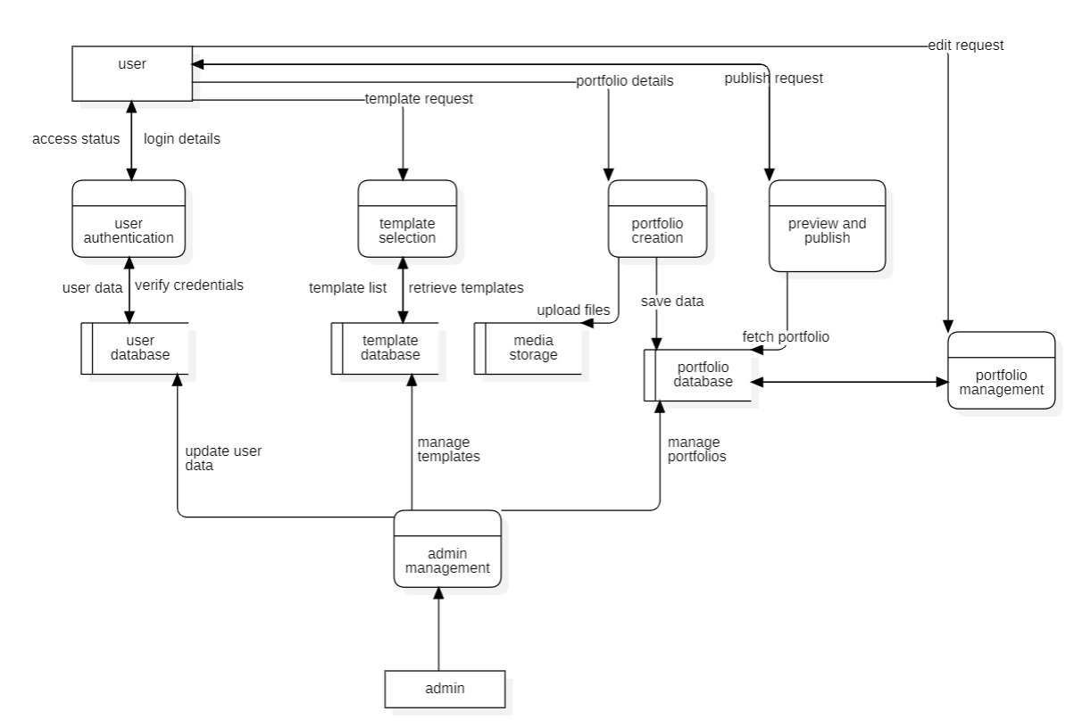

- External Interface Requirements/Screenshots
  - User Interfaces
• The system provides a simple and user-friendly web interface.
• The design will be simple and easy to understand.
• The system is responsive and works on desktop, laptop, tablet, and mobile.
• Home page contains website title, navigation bar, and Get Started button.
• Registration page includes Name, Email, Password fields.
• Login page includes Email, Password, and Forgot Password option.
• Dashboard allows users to create, edit, preview, and publish portfolio.
• Template page allows users to select and customize templates.
• Portfolio editor allows adding About, Skills, Projects, Resume, and Contact sections.
• Admin page allows managing users and templates.

  - Hardware Interfaces
• The system operates on desktop, laptop, tablet, and smartphone.
• Internet connection is required.
• Basic input devices like keyboard and mouse are sufficient.
• Server is required to host the application and store data.
• No special hardware devices are needed.

  - Software Interfaces
• The system works on modern web browsers.
• It supports operating systems like Windows, Linux, and macOS.
• A database is used to store user and portfolio information.
• An email service is used for account verification and password recovery.
• The application is hosted on a web server.

  - Communication Interfaces
• The architecture of the system is based on a client-server model.
• Communication happens through the internet.
• Data transfer uses HTTP or HTTPS protocols.
• User data is transmitted securely.
• Access to the internet is necessary for all key operations

5. Other Non-Functional Requirements
5.1 Performance Requirements
• The system should load pages fast, within a few seconds, when there is an internet connection.
• The system should be able to handle multiple users at the same time. It should not slow down when many users are using the system and must continue to work properly for all users.
•The portfolio preview and portfolio publishing processes should work quickly so users do not have to wait for a long time.
• The images and documents that users upload should function properly without any
issues
• The system should respond quickly to user actions such as saving and editing content.

5.2Safety Requirements
• We need to make sure that user data is kept in a place so that it does not get lost by accident. This means that user data should be protected and stored safely without any risk of loss of user data.
• We need to make sure we have backups so that we do not lose our important data. This way we can keep our data safe with backups.
• The system should be able to deal with things that go wrong without stopping. When something unexpected happensthe system should keep working and not crash.
• We need to check the files that people upload to make sure that they do not have any harmful content.
• Proper data privacy guidelines should be followed.

5.3 Security Requirements
• Every user must log in using valid credentials to access their account.
•Passwords should be stored in encrypted format.
• HTTPS protocol must be used to ensure secure communication.
• Unauthorized users should not be allowed to access private data.
• Admin access should be protected with strong authentication.
• The system should prevent common attacks like SQL injection.
• Session management should automatically log out inactive users.
• User data must not be shared with third parties without permission.

5.4 Software Quality Attributes
• The system should be reliable and available most of the time.
• The thing is this should be simple, for people who are just starting out like beginners. Beginners need beable to use it without getting confused.
• The interface should be consistent and user-friendly.
• The system needs to be simple, to fix and easy to update so that the system is always working well. This means the system should be easy to update.
• It should be compatible with different devices and browsers.

5.5Business Policies/Rules (if any)
• Users must register before creating a portfolio.
• Every user gets an amount of space to store things.
• Premium features may be available only to certain users.
• People who use this service are in charge of the things they put on it. They have to make sure the content they upload is okay.
• The administrator has the right to remove inappropriate content.

- Testing
Template selection module
  - White-Box Testing
CODE:
import unittest
def select_template(template_name, color, layout):
templates = ["Modern", "Classic", "Minimal", "Creative"]
if template_name == "":
return "Template Required"
if template_name not in templates:
return "Template Not Found"
if color == "":
return "Color Required"
if color not in ["blue", "black", "white", "green"]:
return "Invalid Color"
if layout == "":
return "Layout Required"
if layout not in ["grid", "single", "portfolio"]:
return "Invalid Layout"
if template_name == "Modern" and layout == "single":
return "Layout Not Supported"
return "Template Selected"

class TestTemplateSelection(unittest.TestCase):
def test_empty_template(self):
self.assertEqual(select_template("", "blue", "grid"),
"Template Required")
def test_template_not_found(self):
self.assertEqual(select_template("Gaming", "blue", "grid"),
"Template Not Found")
def test_empty_color(self):
self.assertEqual(select_template("Modern", "", "grid"),
"Color Required")
def test_invalid_color(self):
self.assertEqual(select_template("Modern", "red", "grid"),
"Invalid Color")
def test_invalid_layout(self):
self.assertEqual(select_template("Modern", "blue", "table"),
"Invalid Layout")
def test_success(self):
self.assertEqual(select_template("Classic", "blue", "grid"),
"Template Selected")
if __name__ == "__main__":
unittest.main()

CONTROL FLOW DIAGRAM:

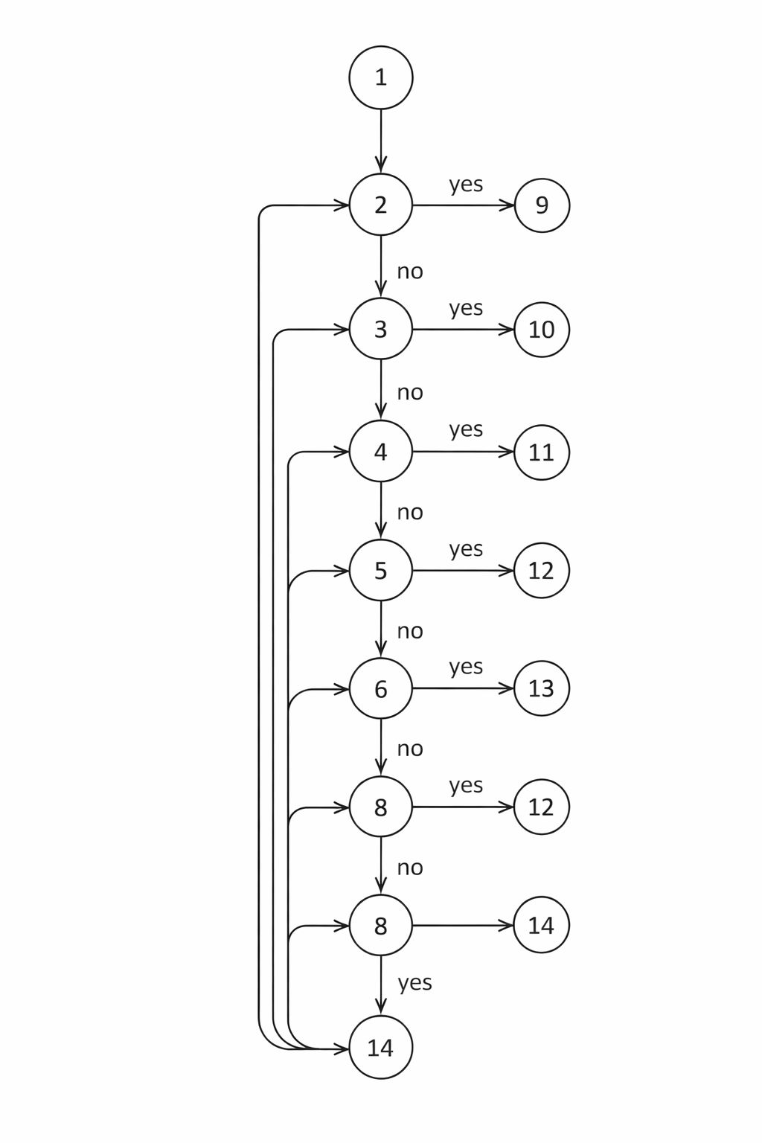

CYCLOMATIC COMPLEXITY:
Cyclomatic Complexity in Software Testing is a testing metric used for measuring the
complexity of a software program.
Cyclomatic complexity can be calculated by using control flow graphs or with respect to
functions, modules, methods or classes within a software program.
V(G)=E-N+2
V(G)=18-14+2
V(G)=6
INDEPENDENT PATHS:
P1: 1 → 2 → 9
P2: 1 → 2 → 3 → 10
P3: 1 → 2 → 3 → 4 → 11
P4: 1 → 2 → 3 → 4 → 5 → 11
P5: 1 → 2 → 3 → 4 → 5 → 6 → 7 → 12
P6: 1 → 2 → 3 → 4 → 5 → 6 → 7 → 8 → 14

DESIGNING TEST CASES:
Test InputExpected Output
('''', "blue", "grid")Template Required
("Gaming","blue","grid")Template Not Found
("Modern","","grid")Color Required
('Modern","red","grid")Invalid Color
("Modern","blue","table")Invalid Layout
("Classic","blue","grid")Template Selected

class TestTemplateSelection(unittest.TestCase):
def test_empty_template(self):
self.assertEqual(select_template("", "blue", "grid"),
"Template Required")
def test_template_not_found(self):
self.assertEqual(select_template("Gaming", "blue", "grid"),
"Template Not Found")
def test_empty_color(self):
self.assertEqual(select_template("Modern", "", "grid"),
"Color Required")
def test_invalid_color(self):
self.assertEqual(select_template("Modern", "red", "grid"),
"Invalid Color")
def test_invalid_layout(self):
self.assertEqual(select_template("Modern", "blue", "table"),
"Invalid Layout")
def test_success(self):
self.assertEqual(select_template("Classic", "blue", "grid"),
"Template Selected")
if __name__ == "__main__":
unittest.main()

OUTPUT:

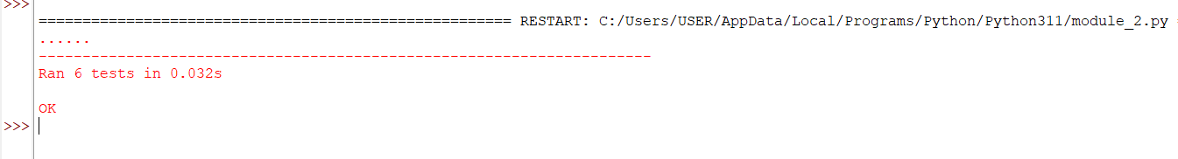

  - Black-Box Testing
1. Equivalence Partitioning
• Equivalence partitioning divides the test cases into different classes of equivalence.
• Each of the classes of equivalence consists of test cases that should produce the same response from the system.
• Instead of testing all the test cases, one test case is chosen from the classes of equivalence.
• This technique minimizes the number of test cases.
• In the Template Selection Module, the test cases such as the name of the template, the color of the template, and the layout of the template can be categorized into valid and invalid classes of equivalence.
• The valid test cases should be accepted by the system, whereas the invalid test cases should prompt an error message.

2. Boundary Value Analysis
• Boundary Value Analysis involves testing the values on the boundaries of the input data.
• The possibility of error is high on the boundaries.
• This analysis involves testing the data on the boundary, below the boundary, and above the boundary.
• The Template Selection Module requires the system to check whether the selected template is available on the list of available templates.
• The system should accept the selected template if the name of the selected template is identical to the name of the available template.
• The system should display an error message if the name of the selected template is different from the available template name.

3. Black-Box Testing Does NOT End with Creating Tables
• Preparing test case tables is just the beginning of Black Box Testing.
• After designing the test cases, the next step is to execute these test cases on the program.
• The inputs obtained from the test case table are fed into the system one by one.
• The actual output of the program is observed carefully.
• This output is compared with the expected output obtained from the table.
• If they match, it is said to be a successful test case.
• If all these test cases are successful, then the Template Selection Module passes the Black Box Testing.

User registration and login module.
6.1 White-Box Testing
CODE:
import unittest
def register_user(username, email, password):
if username == "":
return "Username Required"
if email == "":
return "Email Required"
if "@" not in email:
return "Invalid Email"
if len(password) < 6:
return "Password Too Short"
if username == "admin":
return "Username Not Allowed"
return "Registration Successful"
class TestRegisterUser(unittest.TestCase):
def test_empty_username(self):
self.assertEqual(register_user("", "user@gmail.com", "123456"),
"Username Required")
def test_empty_email(self):
self.assertEqual(register_user("user", "", "123456"),
"Email Required")
def test_invalid_email(self):
self.assertEqual(register_user("user", "gmail.com", "123456"),
"Invalid Email")
def test_short_password(self):
self.assertEqual(register_user("user", "user@gmail.com", "123"),
"Password Too Short")
def test_invalid_username(self):
self.assertEqual(register_user("admin", "user@gmail.com", "123456"),
"Username Not Allowed")
def test_success(self):
self.assertEqual(register_user("Ishitha", "ishitha@gmail.com", "123456"),
"Registration Successful")
if __name__ == "__main__":
unittest.main()

CONTROL FLOW DIAGRAM:

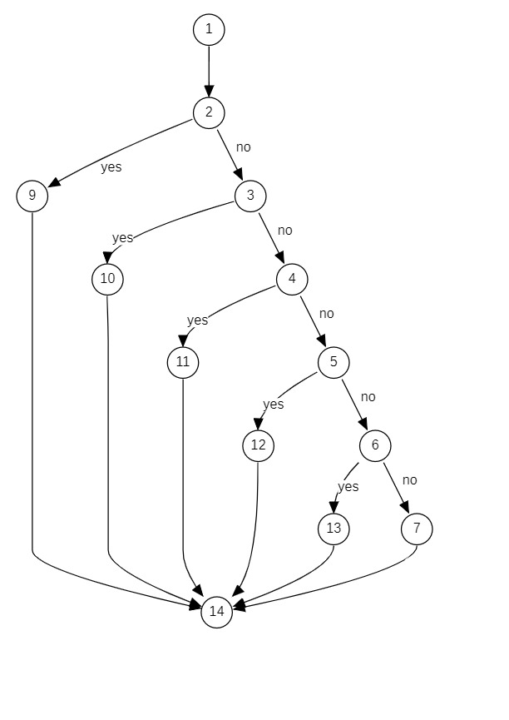
CYCLOMATIC COMPLEXITY:
Cyclomatic Complexity in Software Testing is a testing metric used for measuring the
complexity of a software program.
Cyclomatic complexity can be calculated by using control flow graphs or with respect to
functions, modules, methods or classes within a software program.
V(G)=E-N+2
V(G)=18-14+2
V(G)=6
INDEPENDENT PATHS:
P1: 1 → 2 → 9→ 14
P2: 1 → 2 → 3 → 10→ 14
P3: 1 → 2 → 3 → 4 → 11→ 14
P4: 1 → 2 → 3 → 4 → 5 → 12→ 14
P5: 1 → 2 → 3 → 4 → 5 → 6 → 13 → 14
P6: 1 → 2 → 3 → 4 → 5 → 6 → 7 → 14

DESIGNING TEST CASES:
Test InputExpected Output
(''",user@gmail.com",123456")Username Required
("user","","123456")Email Required
(''user","gmail.com","123456")Invalid Email
("user","user@gmail.com","123")Password Too Short
("admin","user@gmail.com","123456")Username Not allowed
("Ishitha","ishitha@gmail.com","123456")Registration Successful

class TestRegisterUser(unittest.TestCase):
def test_empty_username(self):
self.assertEqual(register_user("", "user@gmail.com", "123456"),
"Username Required")
def test_empty_email(self):
self.assertEqual(register_user("user", "", "123456"),
"Email Required")
def test_invalid_email(self):
self.assertEqual(register_user("user", "gmail.com", "123456"),
"Invalid Email")
def test_short_password(self):
self.assertEqual(register_user("user", "user@gmail.com", "123"),
"Password Too Short")
def test_invalid_username(self):
self.assertEqual(register_user("admin", "user@gmail.com", "123456"),
"Username Not Allowed")
def test_success(self):
self.assertEqual(register_user("Ishitha", "ishitha@gmail.com", "123456"),
"Registration Successful")
if __name__ == "__main__":
unittest.main()

OUTPUT:
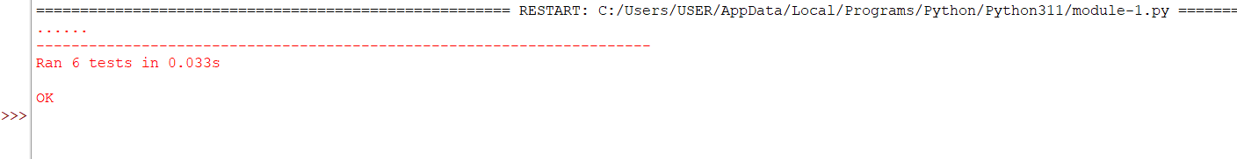

6.2 Black-Box Testing
- Equivalence Partitioning
• The inputs are divided into different classes, known as equivalence classes.
• The inputs in a class are expected to produce the same output in the program.
• Rather than testing all inputs, a test case is chosen from each class.
• This technique is used to decrease the number of test cases.
• In the User Registration and Login Module, inputs such as username, email, and password can be classified into valid and invalid classes.• Valid inputs are accepted by the program and enable the user to register.
• The program should display error messages such as “Username Required,” “Invalid Email,” or “Password Too Short” for invalid inputs.
• This is done to test that the program behaves well for valid and invalid inputs.

- Boundary Value Analysis
• Boundary Value Analysis is a testing technique that tests the values on the boundary or limits of the range.
• It is likely that there are more chances of errors on the boundaries or limits.
• This testing technique tests the values on the lower side, on the boundary, and on the higher side of the boundary.
• In the User Registration and Login Module, the program checks if the length of the password is meeting the minimum length.
• If the length of the password is less than 6, then the program should display the message “Password Too Short.”
• If the length of the password is exactly 6, then the program should accept the password.
• If the length of the password is more than 6, then the program should accept the password.

- Black-Box Testing Does NOT End with Creating Tables
• Preparing test case tables is just the first part of Black Box Testing.
• Once the test cases are created, the next part is to execute the test cases on the program.
• The inputs from the test case table are provided to the program one by one.
• The actual output from the program is observed.
• The actual output is then compared with the expected output provided in the test case table.
• If the actual output and the expected output are the same, then the test case is said to be successful.
• If all test cases are successful, then the User Registration and Login Module passes the Black Box Testing.

- Conclusion
• The Portfolio Website Builder helps users make and manage their portfolio websites easily.
• This system lets users register log in pick a template create a portfolio edit it preview it and publish it.
• It helps students, freelancers and professionals show their work, skills and achievements in a way.
• The system makes it easy to build a website by providing made templates and easy customization options.
• It is designed to be secure perform well and be reliable so it works safely and smoothly.
• We tested the system thoroughly using methods to make sure all the parts work correctly.
• This project shows how a user-friendly system can help people create professional portfolios without needing to know a lot of tech stuff.

- References
• Software Engineering: A Practitioner's Approach – Used for understanding software development processes and design principles.
• Software Engineering – Referenced for software requirement specification and system design concepts.
• StarUML – Used to design UML diagrams such as use case diagrams, class diagrams, sequence diagrams, and component diagrams.
• Python documentation – Used for understanding basic program structure and testing implementation.
• MySQL documentation – Referenced for database concepts and data storage.
• Official documentation and online resources related to web application development and UML modeling.

- Acknowledgements
• I sincerely thank my faculty for their valuable guidance and support.
• I appreciate the help and encouragement from my friends and classmates.

DESIGN PHASE

COMPONENT DIAGRAM:

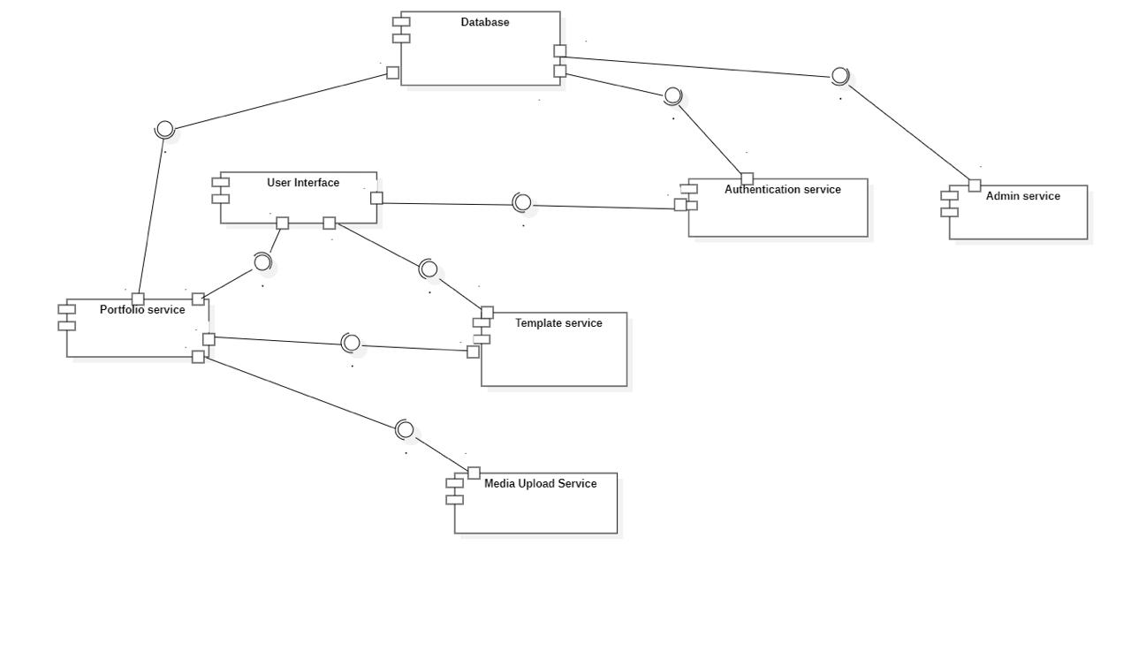

DESCRIPTION:
• The Component Diagram illustrates the various components of the Portfolio Website Builder system and their interaction with each other.
• The components of the system are the User Interface, Authentication Module, Template Management Module, Portfolio Management Module, Admin Management Module, and Database.
• The interfaces provided are user authentication services, portfolio creation services, template selection services, and admin management services.
• The interfaces to be provided are database services for storing user data and portfolio data, email services for verification and password recovery, and media upload services for uploading images/documents.

DEPLOYMENT DIAGRAM:

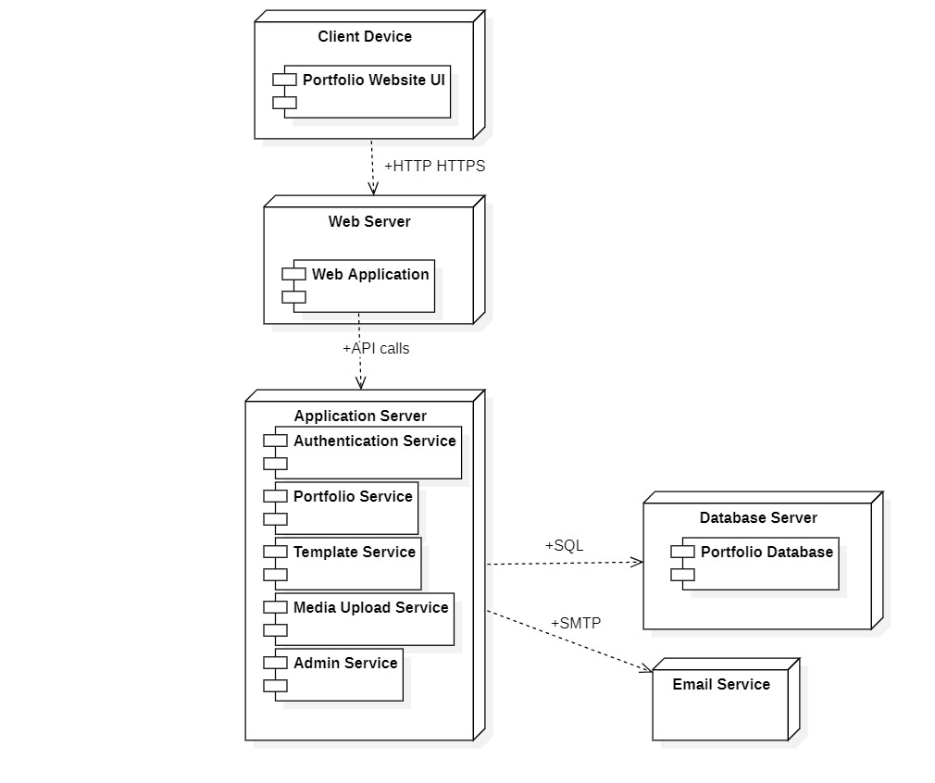

DESCRIPTION:
• The Deployment Diagram describes the physical view of the Portfolio Website Builder system.
• The system architecture is client-server. The users access the system through a web browser on a computing device such as a desktop computer, laptop computer, tablet computer, or smartphone.
• The web server hosts the application and processes user requests.
• The application server processes system logic such as user authentication, template selection, and portfolio management.
• The database server stores user data, templates, portfolio data, and uploaded media content.
• The client and server communicate through HTTP or HTTPS over the internet.

METRICS FOR ANALYSIS MODEL

UFP CALCULATION

Information Domain Value | Count | Weighting Factor  (Simple) | Weighting Factor  (Average) | Weighting Factor  (Complex) | Selected Weight | Result
External inputs (EIs) | 10 | 3 | 4 | 6 | 4 | 40
External outputs (Eos) | 7 | 4 | 5 | 7 | 5 | 35
External inquiries (EQs) | 4 | 3 | 4 | 6 | 4 | 16
Internal logical files (ILFs) | 4 | 7 | 10 | 15 | 10 | 40
External interface files (EIFs) | 2 | 5 | 7 | 10 | 7 | 14

Count Total(UFP)
UFP=40+35+16+40+14
UFP=145

VAF CALCULATION
1. Does the system require reliable backup and recovery?
2. Are specialized data communications required to transfer information to or from the application?
3. Are there distributed processing functions?
4. Is performance critical?
5. Will the system run in an existing, heavily utilized operational environment?
6. Does the system require online data entry?
7. Does the online data entry require the input transaction to be built over multiple screens or operations?
8. Are the ILFs updated online?
9. Are the inputs, outputs, files, or inquiries complex?
10. Is the internal processing complex?
11. Is the code designed to be reusable?
12. Are conversion and installation included in the design?
13. Is the system designed for multiple installations in different organizations?
14. Is the application designed to facilitate change and ease of use by the user?

Rating Scale:
0 - No Influence
1 - Incidental
2 - Moderate
3 - Average
4 - Significant
5 – Essential

Fi=Value Adjustment Factor for each of the 14 questions
We assume Fi=3 for all 14 factors.
(for Portfolio Website Builder, most system characteristics online entry, database updates, security, usability, backup, etc. fall under Average influence.)

Formula:
CAF = 0.65 + (0.01*Σ Fi)

Calculation
Σ Fi = 14*3
Σ Fi = 42
Now substitute into the formula:
CAF = 0.65 + (0.01*42)
CAF = 0.65 + 0.42
CAF = 1.07

Final Function Points
UFP = 145
FP = UFP * CAF
FP = 145*1.07
FP = 155.15

The Function Point Analysis estimates the functional size of the Portfolio Website Builder system to be approximately 155 Function Points, indicating a medium-complexity web application.

Assumption:
Assumption:
If 1 FP = 10 hours of development.
Total development hours = 155.5 × 10 = 1555 hours

Number of developers = 4
Working hours per day for each developer = 8 hours
Total team working hours per day = 4 × 8 = 32 hours

Project Duration = 1555 / 32 = 48.59 days ≈ 49 days

Cost per hour = ₹500
Estimated project cost = 1555 × 500 = ₹7,77,500

Empirical Estimation Models
COCOMO MODEL

1. Basic COCOMO Model

• The Basic COCOMO can be used for quick and slightly rough calculations of Software Costs.

• The following formulas are used to calculate effort and time estimates.

Effort ( E ) = A*(KLOC)^B

Time (T) = C*(Effort)^D

Persons required = Effort / Time

• The constant values A, B, C and D for the Basic Model for the different categories of software projects.

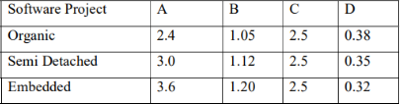

• My project is estimated to have 7.75 KLOC hence comes under Organic Mode.

• Effort ( E ) = A*(KLOC)^B

E = 2.4 * (7.75)^1.05 = 20.92 Person-Months

• Time (T) = C*(Effort)^D

T = 2.5 * (20.92)^0.38 = 7.95 Months

• Persons Required = Effort / Time

P = 20.92 / 7.95 = 2.63 ≈ 3 Persons

2. Intermediate COCOMO Model

• EAF = Product of cost drivers

• The Intermediate COCOMO model formulas are

Effort ( E ) = (A*(KLOC)^B ) * EAF.

Time (T) = C*(Effort)^D

Persons required = Effort / Time

• EAF = Product of all values

EAF = 1.10 * 1.00 * 1.00 * 1.00 * 1.00 * 1.00 * 1.00 * 0.90 * 1.00 * 1.08 * 1.05 * 1.00 * 0.95 * 1.00 * 1.00

EAF = 1.07

• Effort ( E ) = (A*(KLOC)^B ) * EAF

E = 3.0 * (7.75)^1.12 * 1.07 = 31.62 Person-Months

• Time (T) = C*(Effort)^D

T = 2.5 * (31.62)^0.35 = 8.37 Months

• Persons required = Effort / Time

P = 31.62 / 8.37 = 3.77 ≈ 4 Persons

